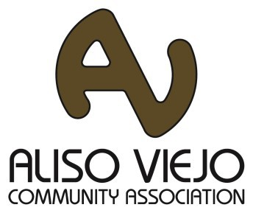
Aliso Viejo Community Association proudly presents...

Fall Harvest Festival

Saturday, October 21, 2017
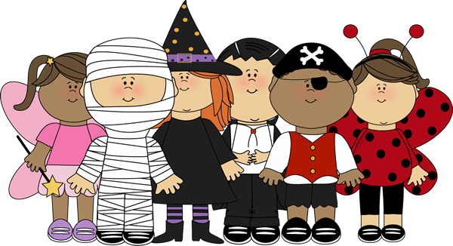
10:00 am - 12:00 pm at Grand Park

Children’s Crafts
- Carnival Games
- Balloon Twisters
- DJ Entertainment
Children’s Costume Parade will be from 10:30 am - 11:30 am

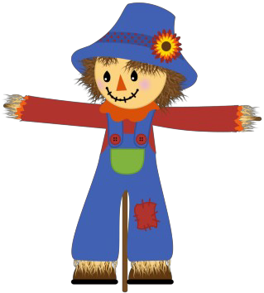Bring FIVE canned food items, pet food or make a donation and your child receives a wristband for a pony ride.
The only way for your child to ride a pony is donate and receive a wristband.

Canned food will be collected and distributed to those in need here in Orange County.
Food Drive Hosted By: South County Outreach

For more information about AVCA visit:
Facebook: www.facebook.com/AVCAEvents Instagram: #AVCAEvents Twitter: www.twitter.com/avcommunity Website: www.avca.net
Call AVCA: 949-243-7750

MOST NEEDED FOOD
Rice · Peanut Butter · Jelly · Soup · Canned Beans Cereal · Juice · Pasta · Pasta Sauce · Top Ramen
Macaroni & Cheese · Chili · Ravioli · Tuna · Canned Fruit

ABOUT SOUTH COUNTY OUTREACH:
Founded in 1989, South County Outreach is a non-profit organization dedicated to helping low income families in South Or- ange County. South County Outreach helps those in crisis reach self- sufficiency by providing the following services: food pantry, rental and utility assistance, homeless prevention counseling and coach-
ing, transitional housing, computer learning lab, thrift store and seasonal programs.
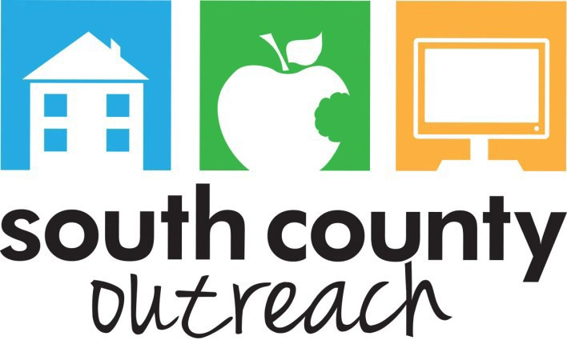
7 Whatney, Suite B, Irvine, CA 92618 · (949) 380-8144 www.sco-oc.org · Tax ID #33-0330233

PLEASE NOTE:
The only way for your
child to ride a pony is donate and receive a wristband!

